Parse TDS Fixed Length File To XML

1. Our sample example file follows:

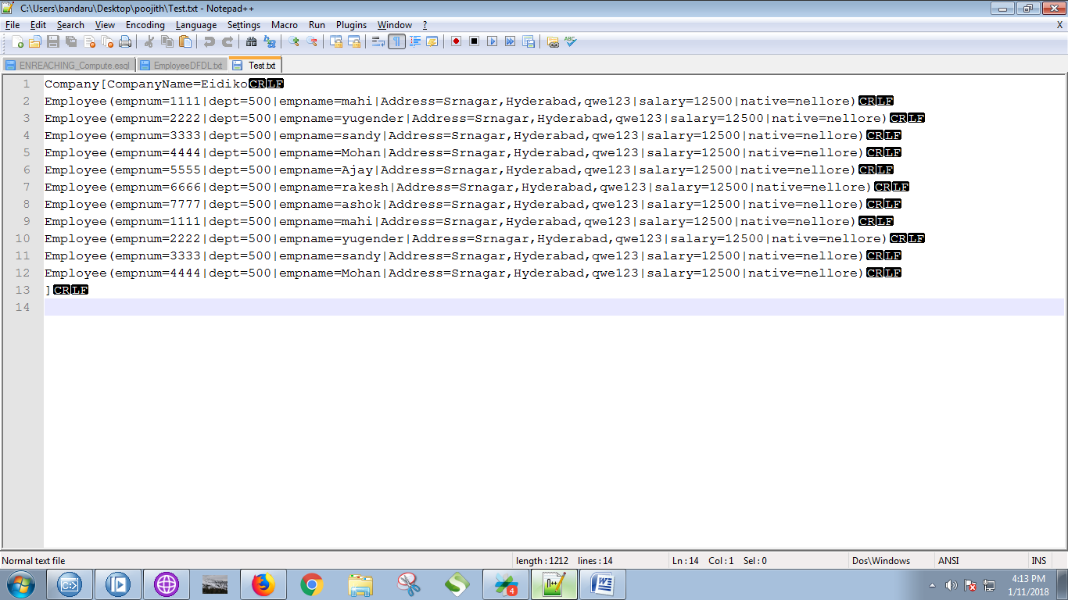

2. Click on "File" and select "New" ==> "Application".

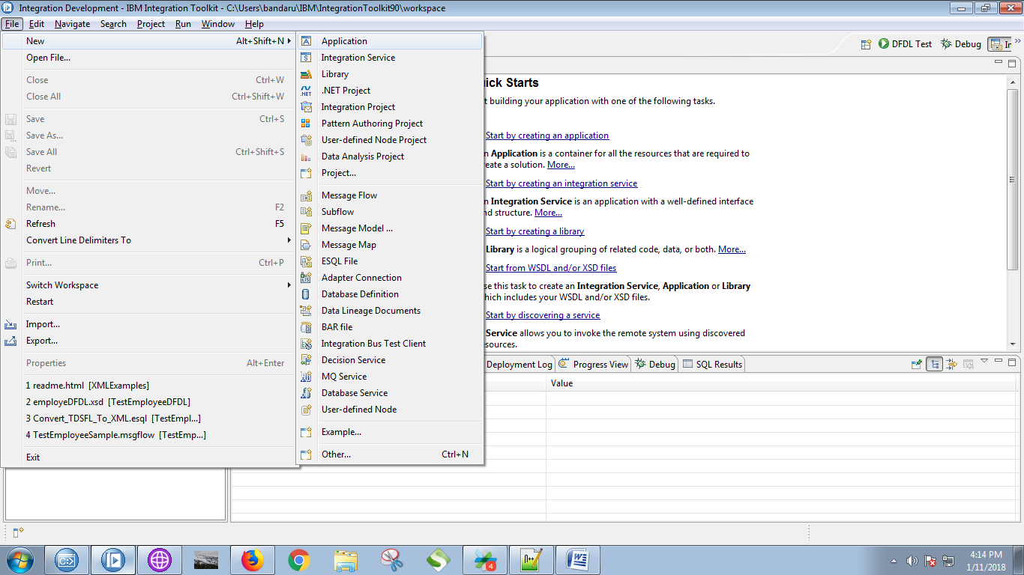

3. Give a name for your application and click on "Finish" button.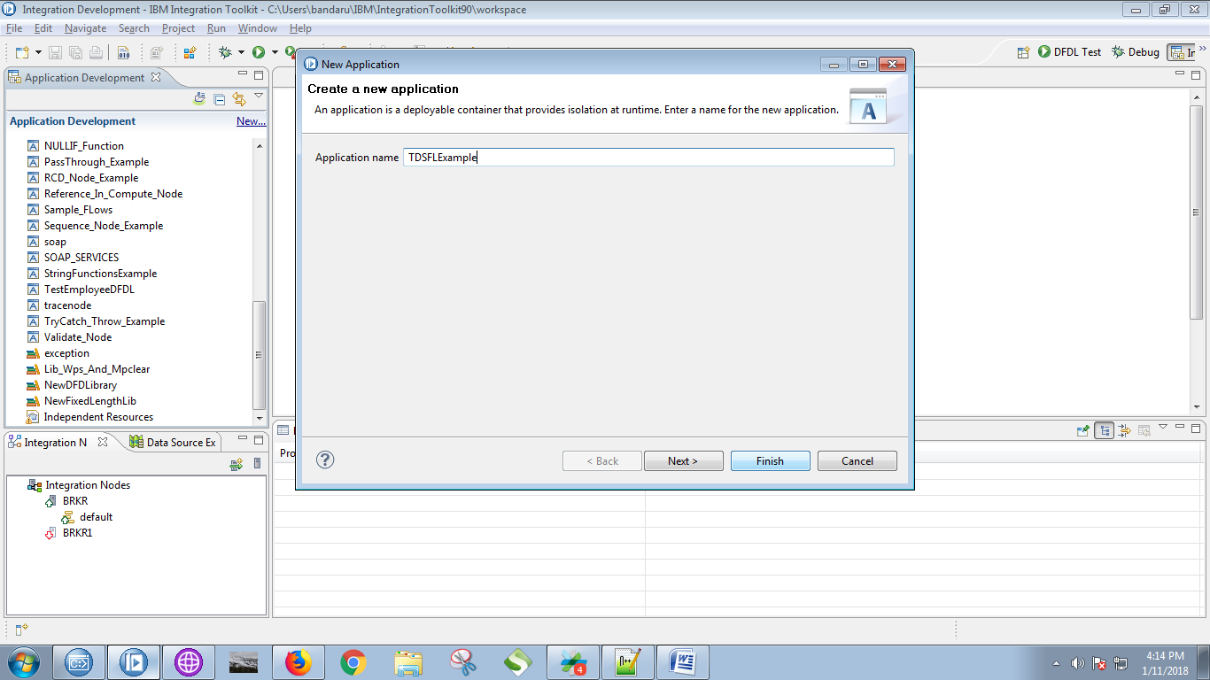

4. Under your application, you able to see "New" click on it.

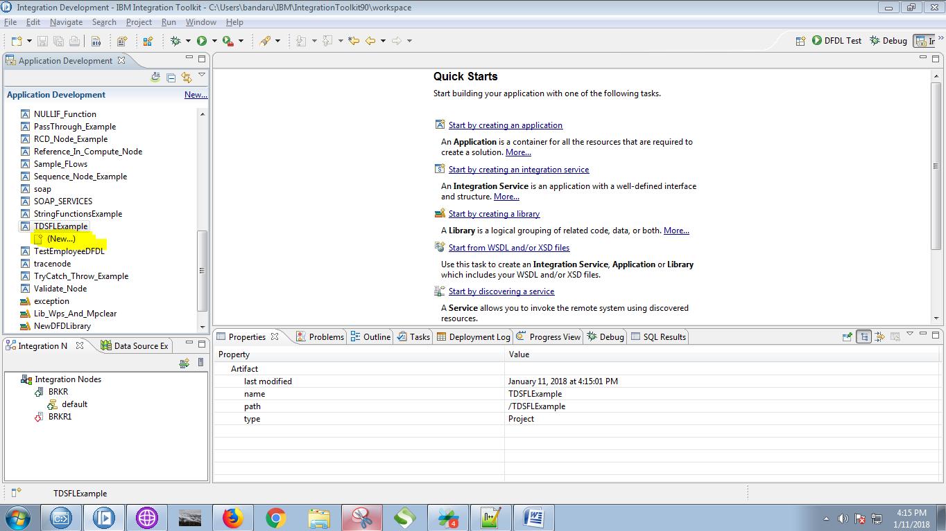

5. Select "Message Model" from the given options.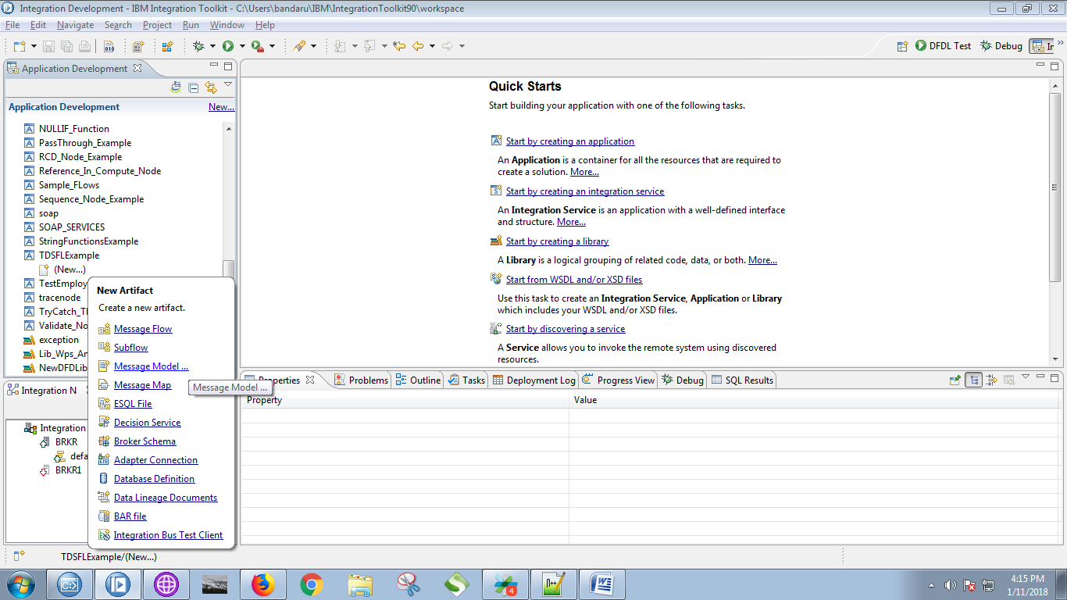

6. Choose "Record-oriented text" from the pop-up appeared.

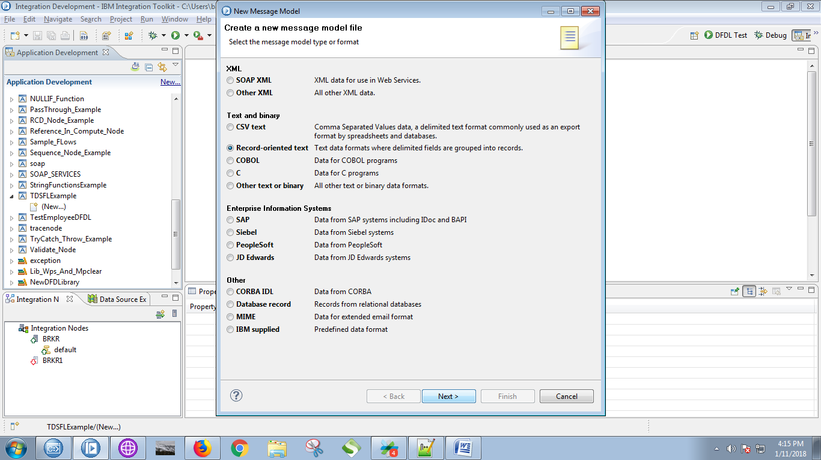

7. Select first radio button when following pop-up appears.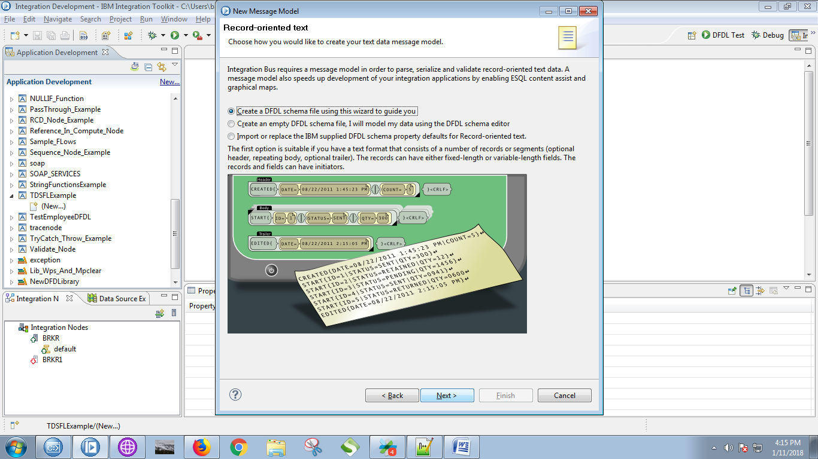

8. Give a name for your DFDL schema and click on "Next" button.

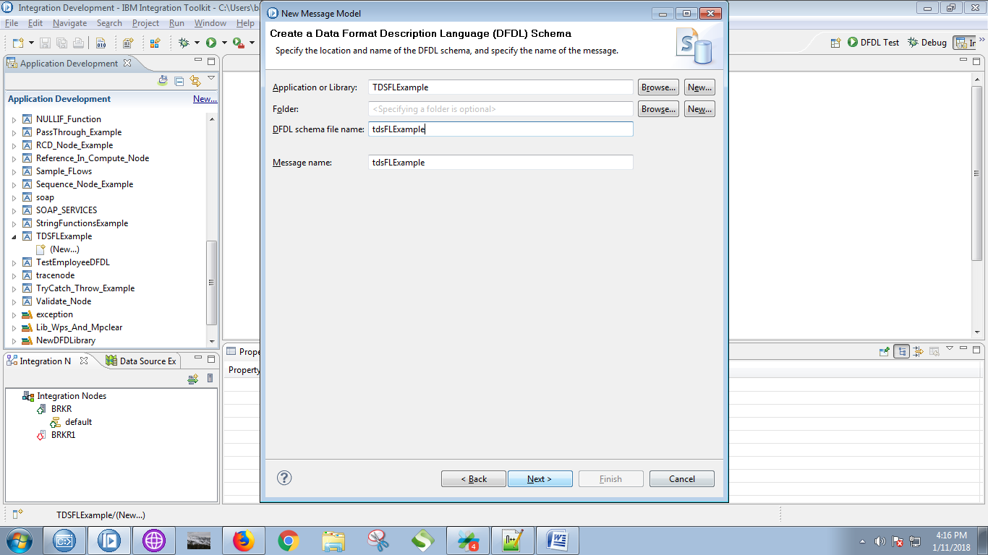

9. Follow the following 'yello' marked steps.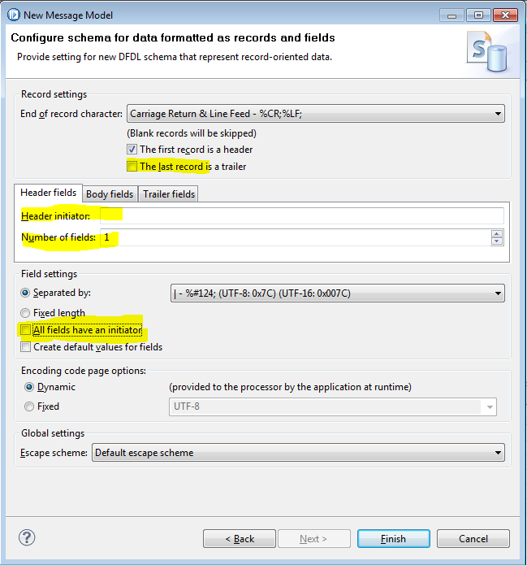

10. Set "Body fields" value and click on "Next" button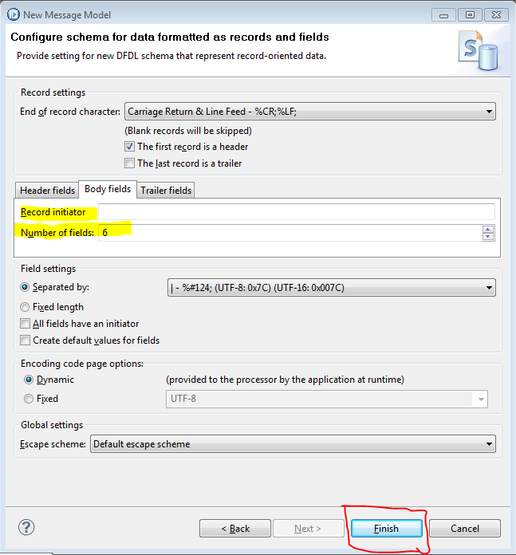

11. Following schema will appears on screen.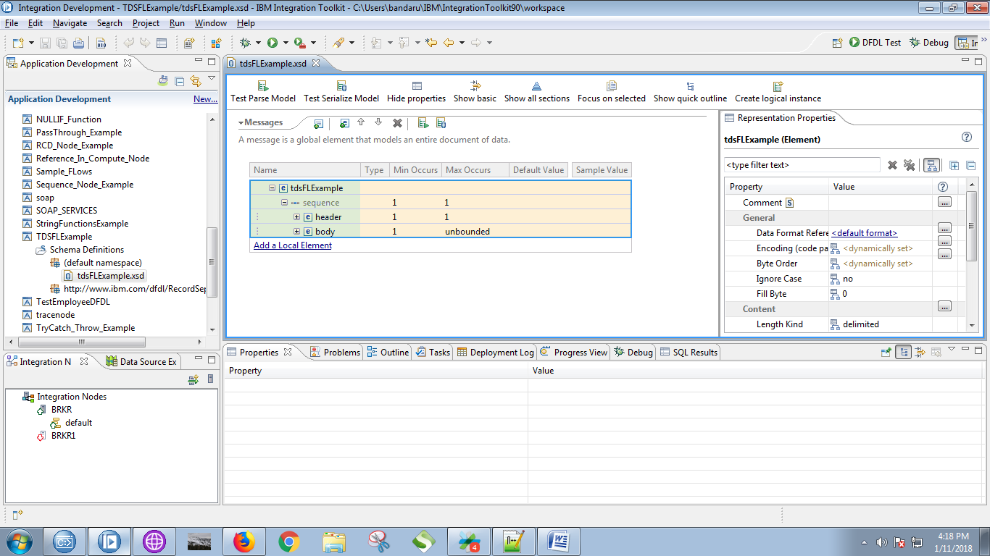

12. Settings for the "sequence" as you can see in below fig.

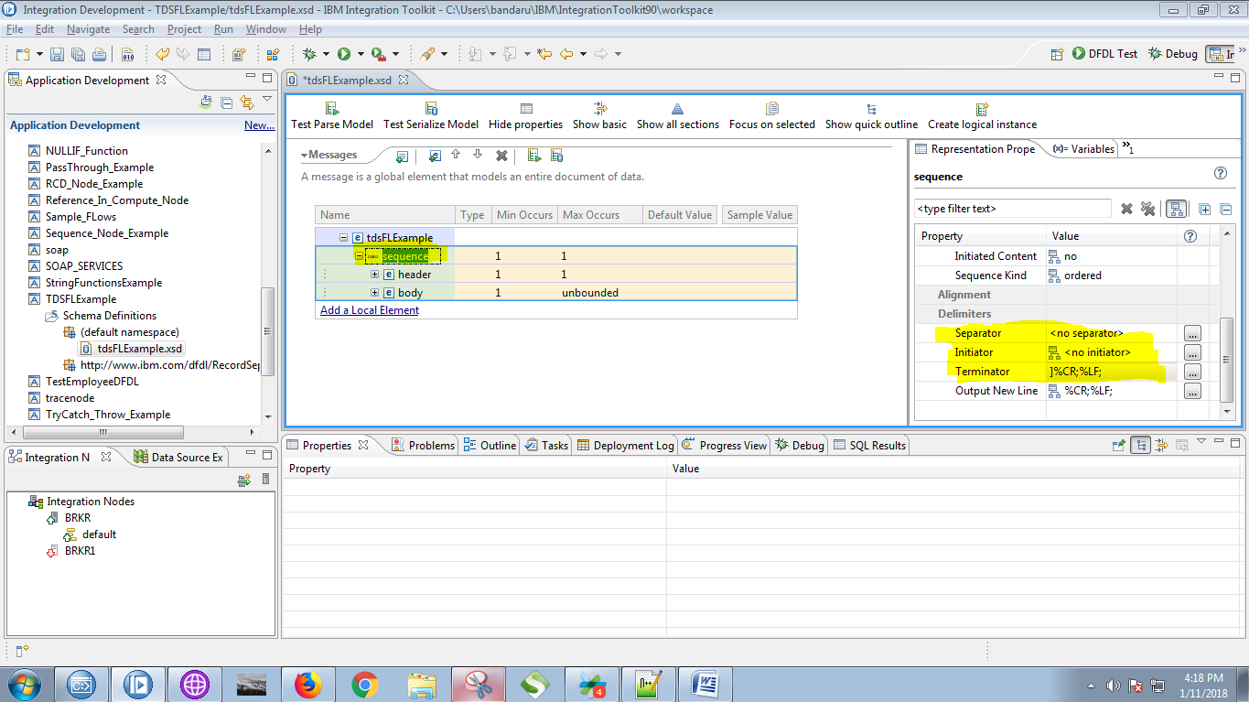

13. Give the names as which your file fields.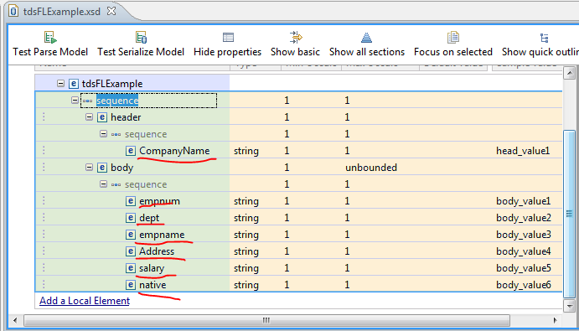

14. Settings for "header" as follows.

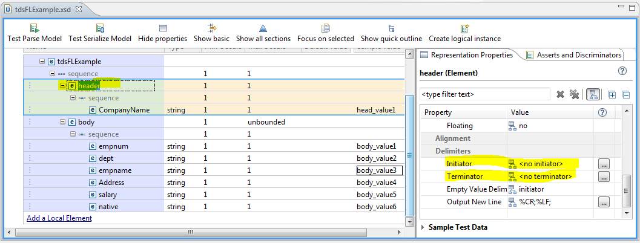

15. Settings for "sequence" under the header as follows.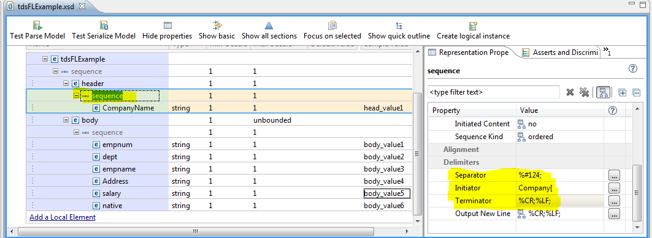

16. Settings for the value under header as follows.

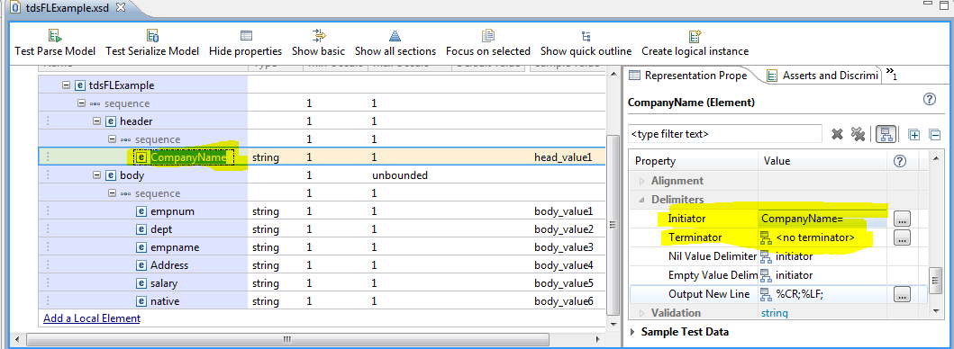

17. Settings for the "body" attribute as follows.

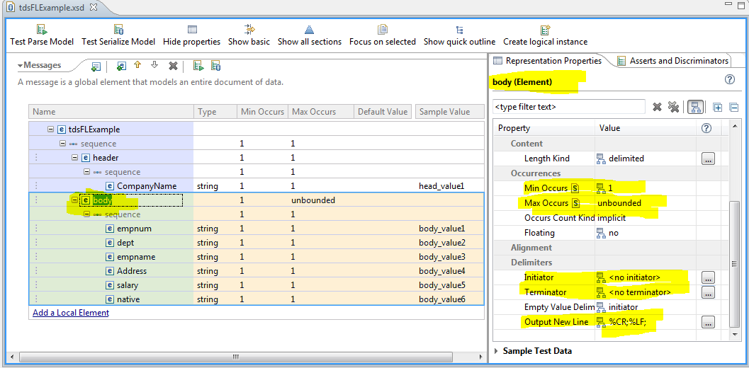

18. Settings for the "sequence" under body section as follows.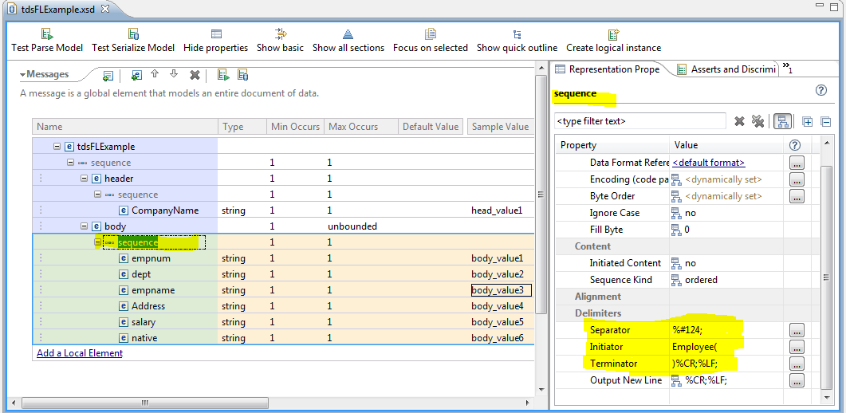

19. For each of the body fields follow the value as in input file, for example "empnum=" is set to "empnum" field, similarly set for the "dept", "empname"...etc. as respectives fields from input file.

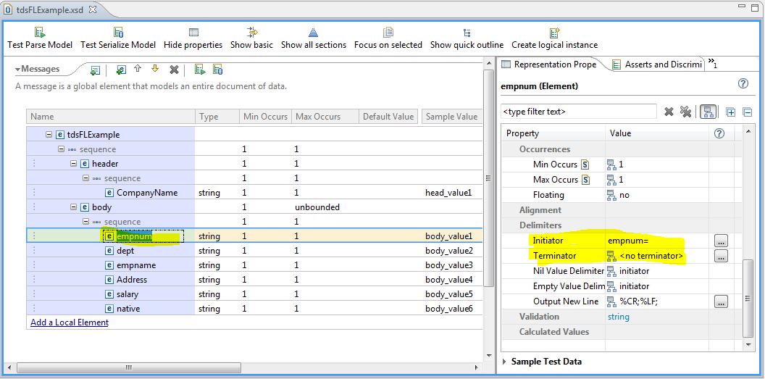

20. Click on "Test PArse Model" as shown in fig.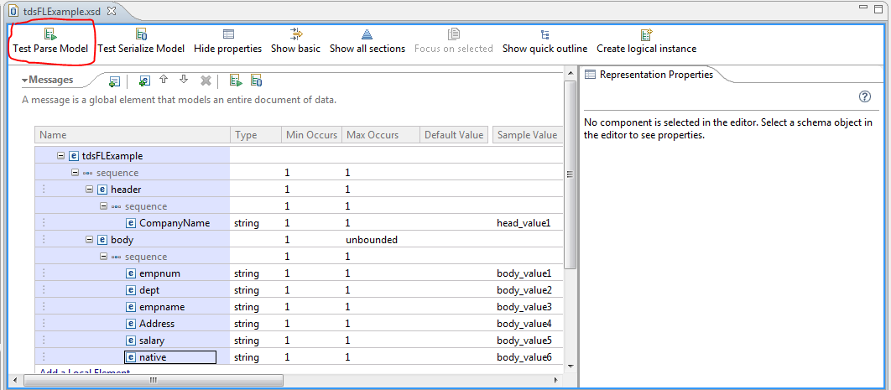

21. Click on "browse" button when following pop-up appears.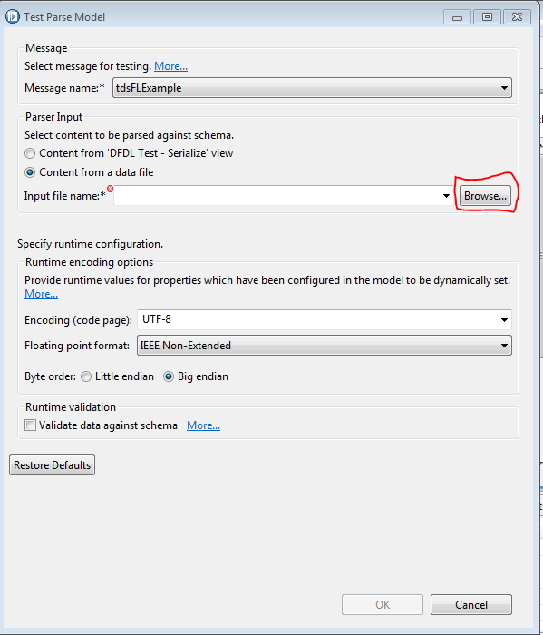

22. Check the bottom check-box and click on "browse" button.

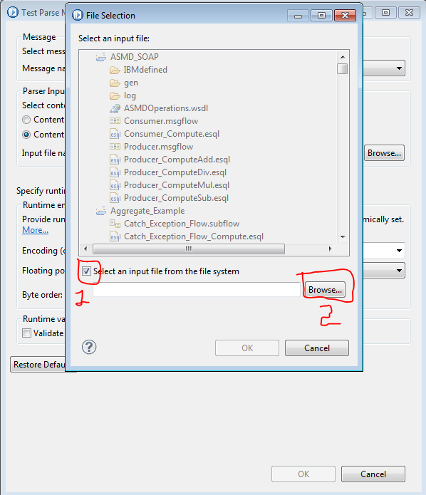

23. Choose your file and click on "OK" button.

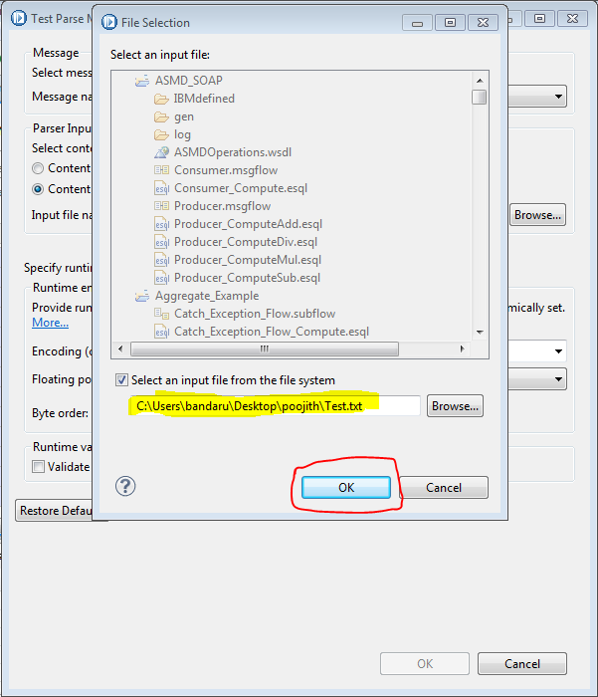

24. Click on "OK" button.

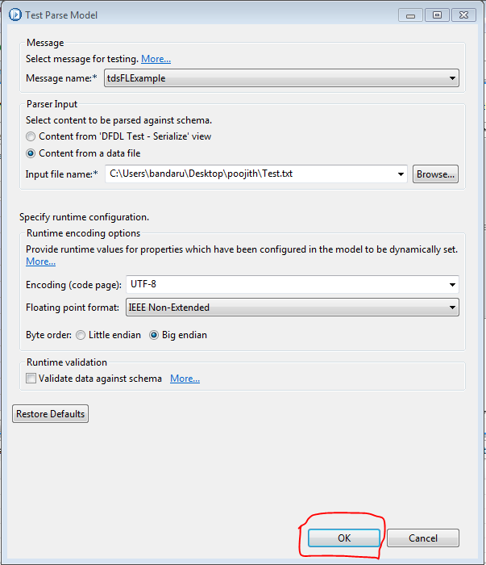

25. You file parsed successfully as shown in below fig.

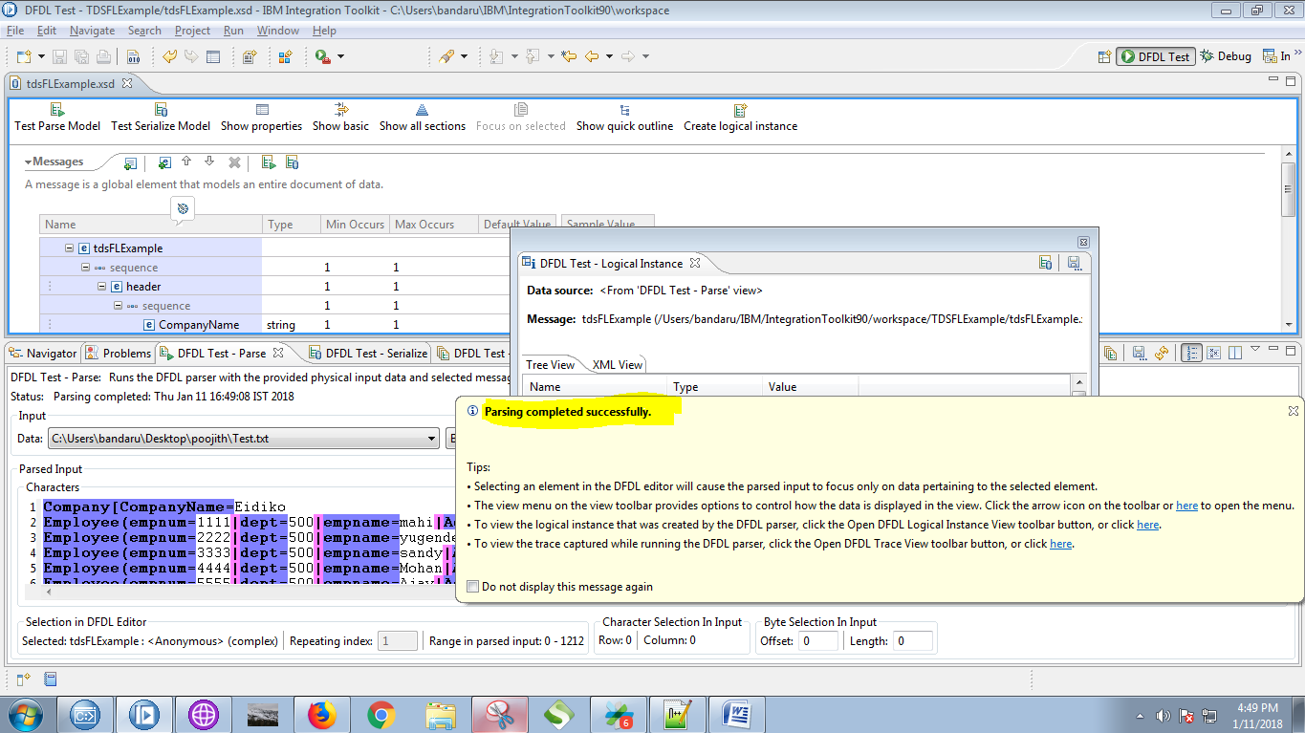

26. You can see parsed values as well.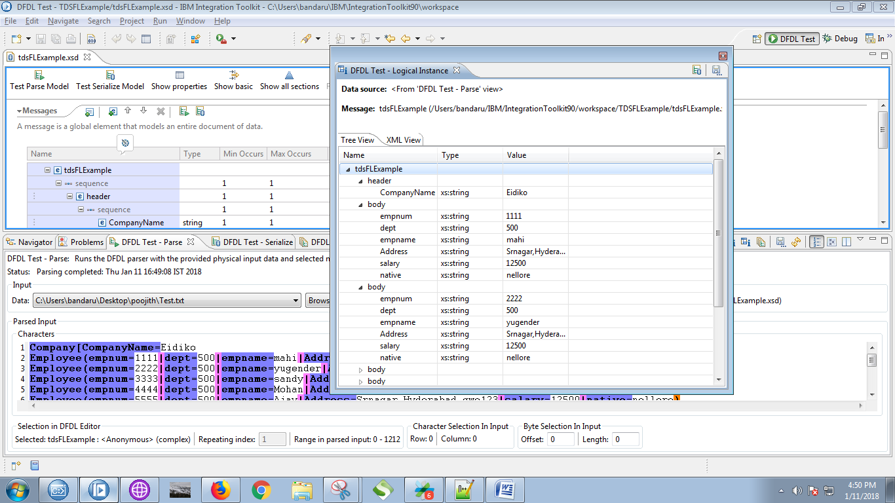

27. Right click on your application and select "New"==> "Message Flow".

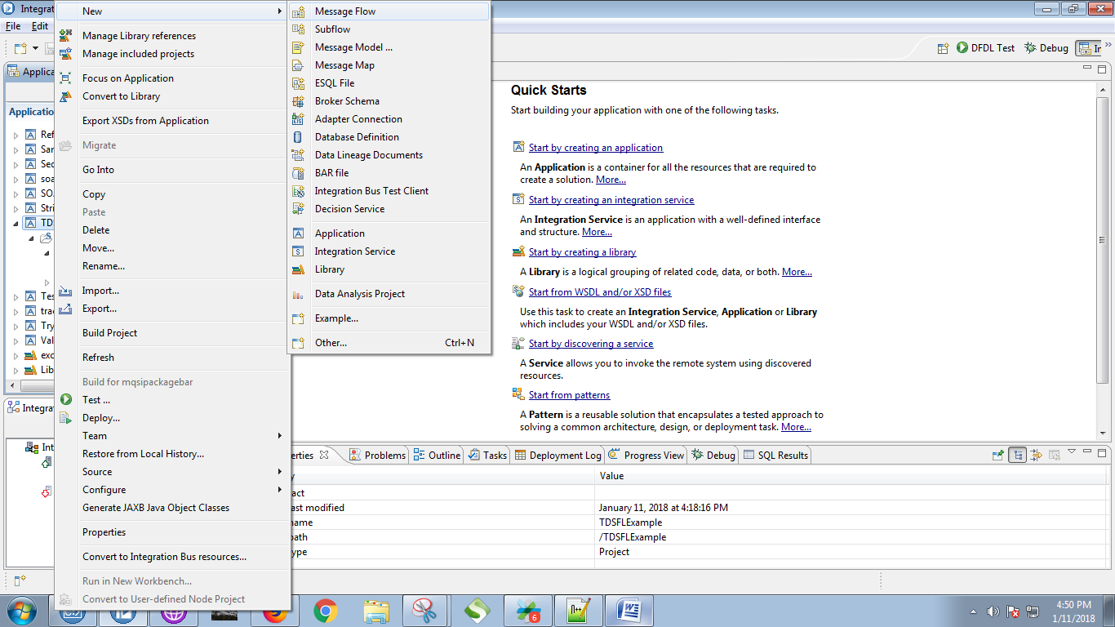

28. Give a name for your flow and click on "Finish" button.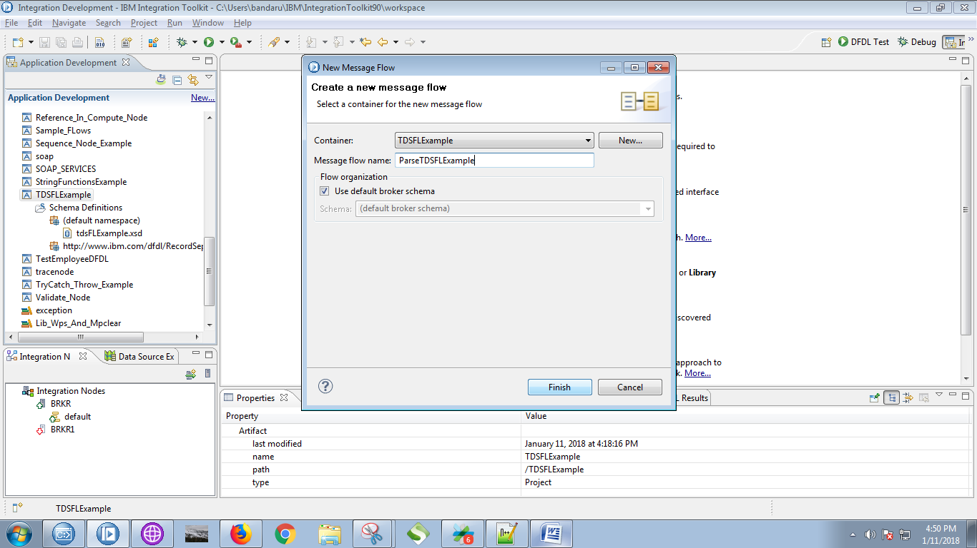

29. Drag the MQInput and give it a name.

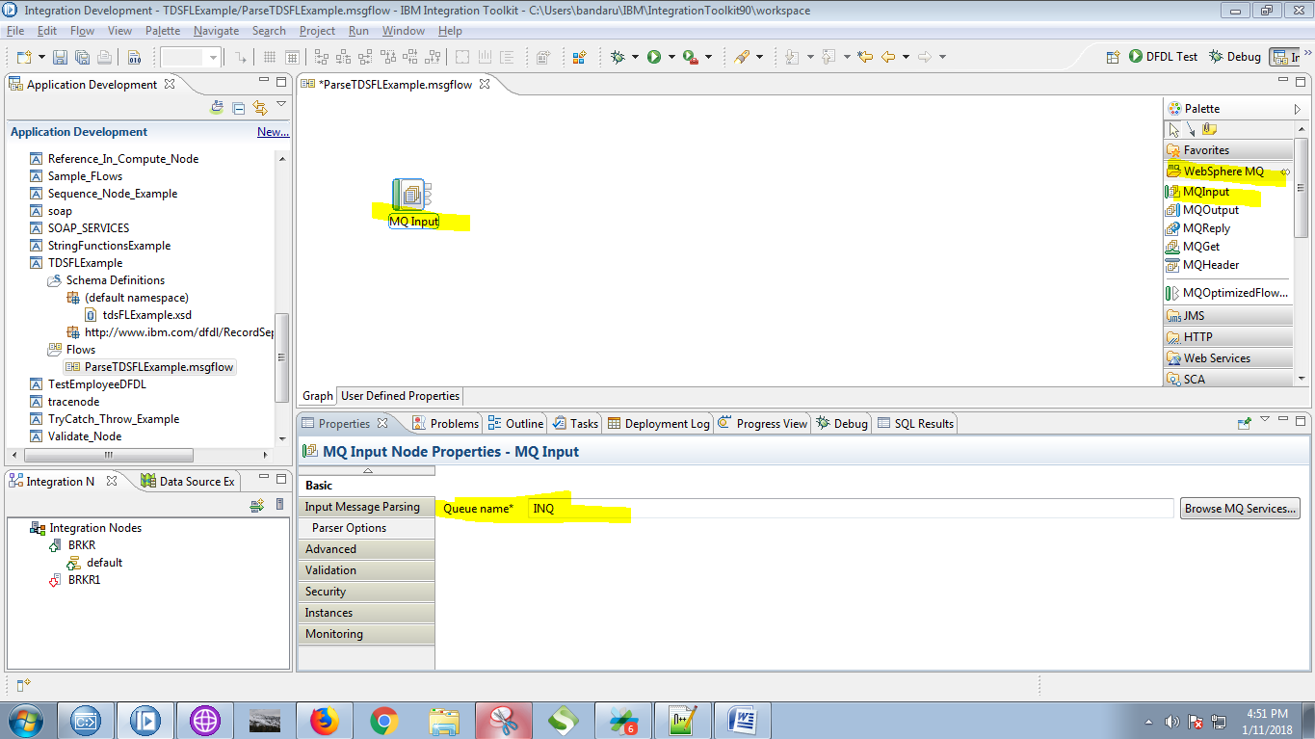

30. Set Message domain to "DFDL" and click on "Browse" button.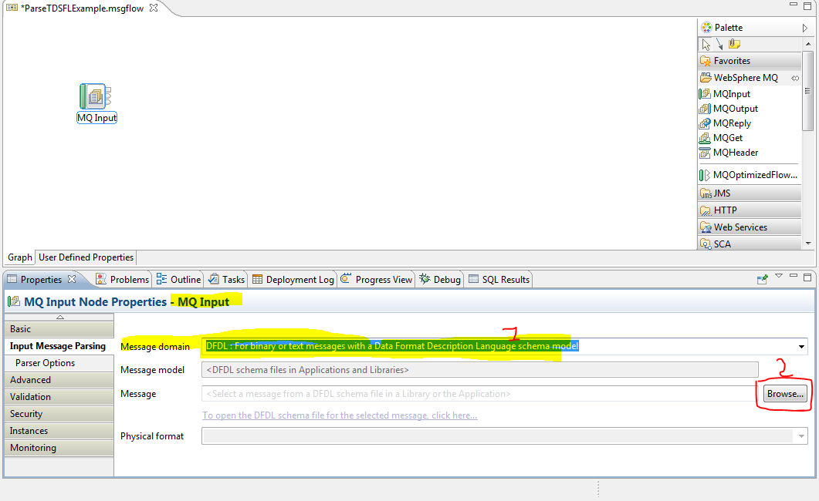

31. Select your DFDL schema and click on "OK" button.

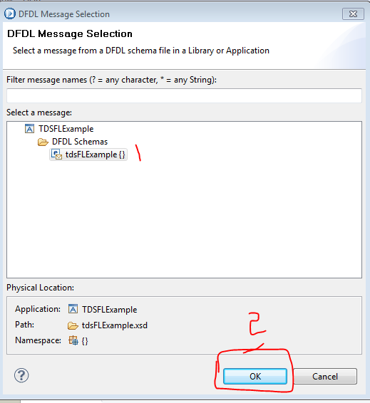

32. Drag the compute node from the palette.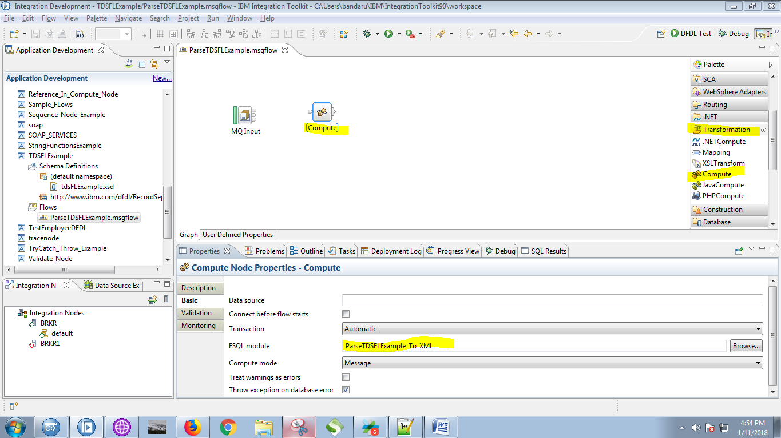

33. Connect "output" terminal of the MQInput with "input" terminal of the compute node.

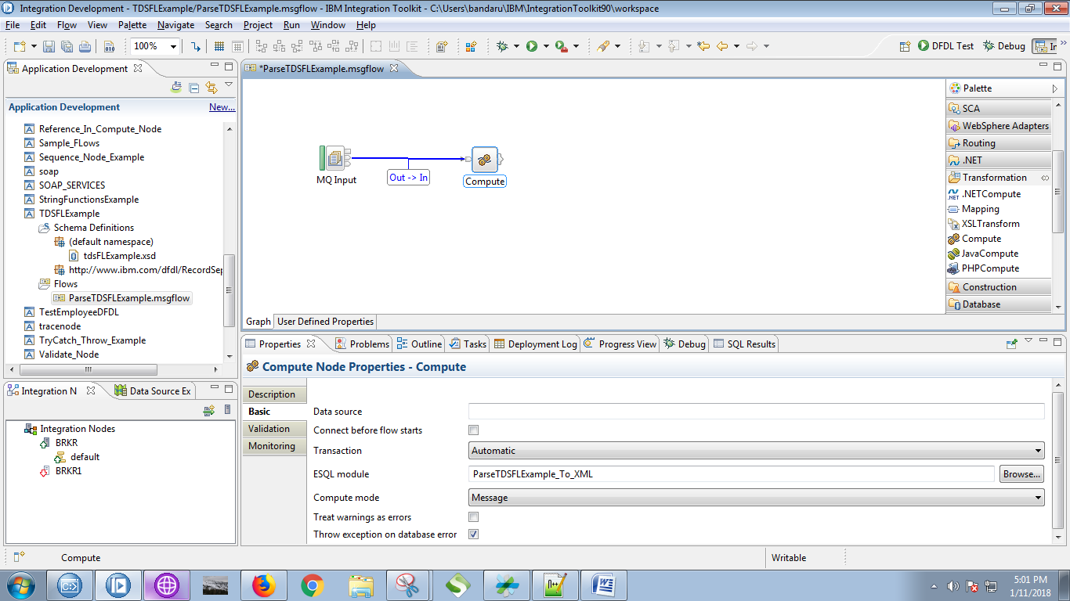

34. Drag the MQOutput from the palette and give it a name.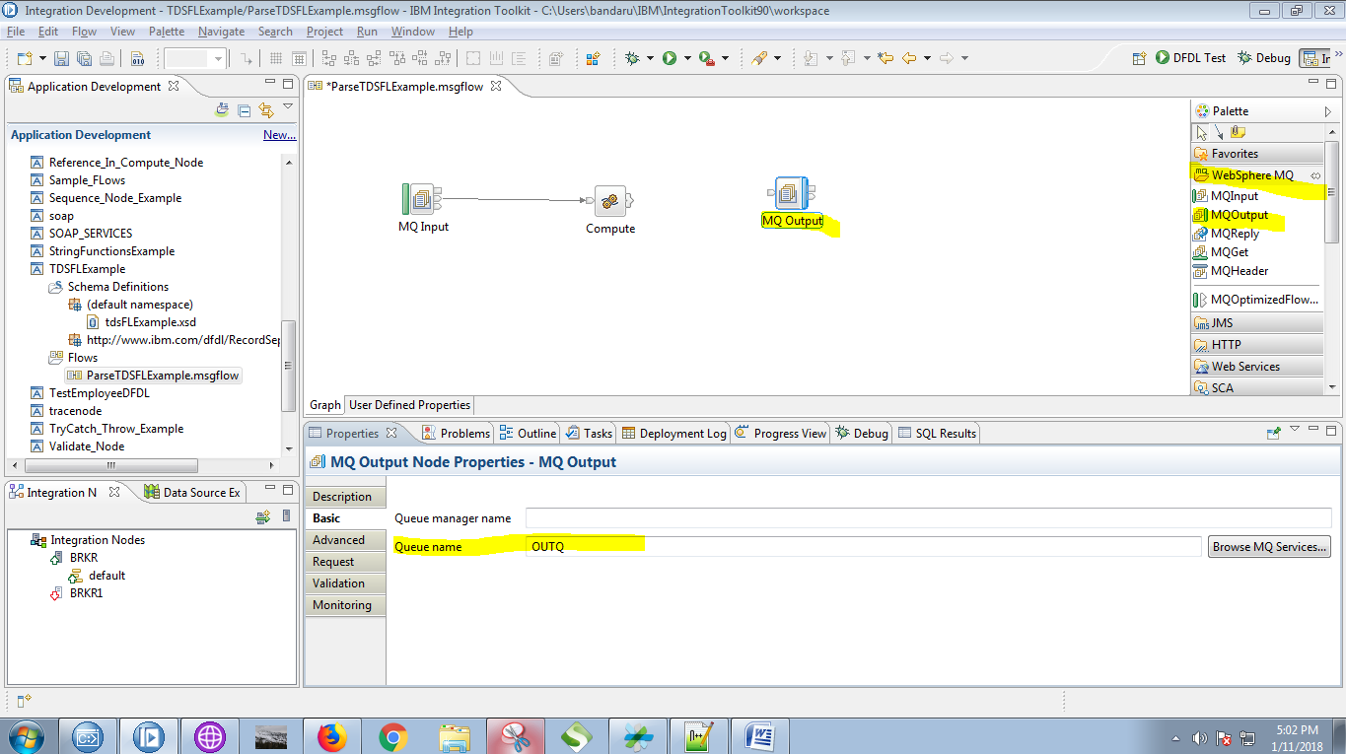

35. Click on output terminals of the compute node and select "Out" terminal and press "OK" button.

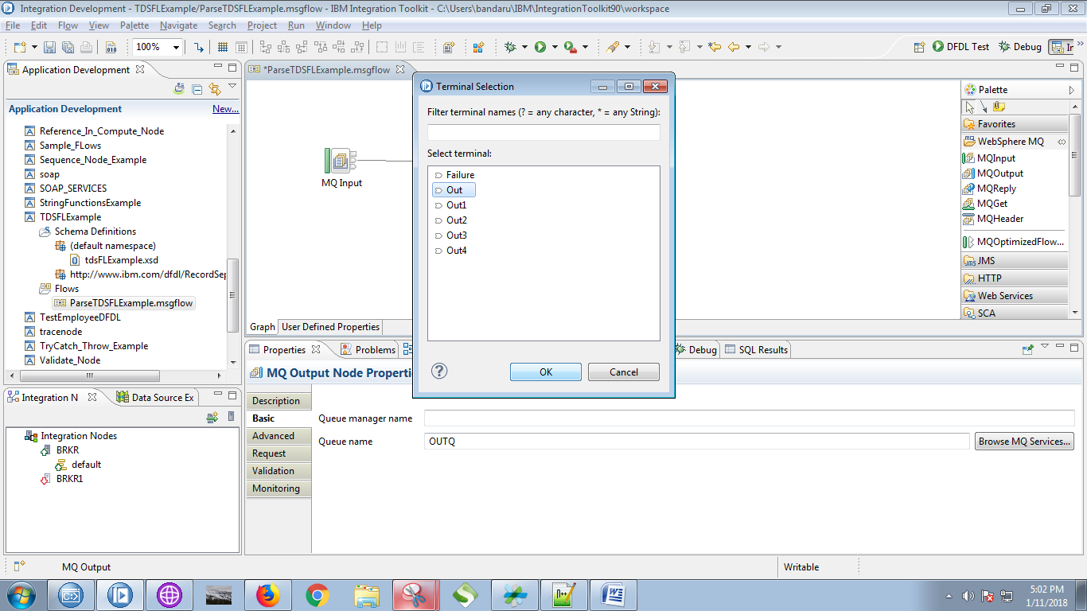

36. Connect "output" terminal of the compute node with "input" terminal of the MQOutput.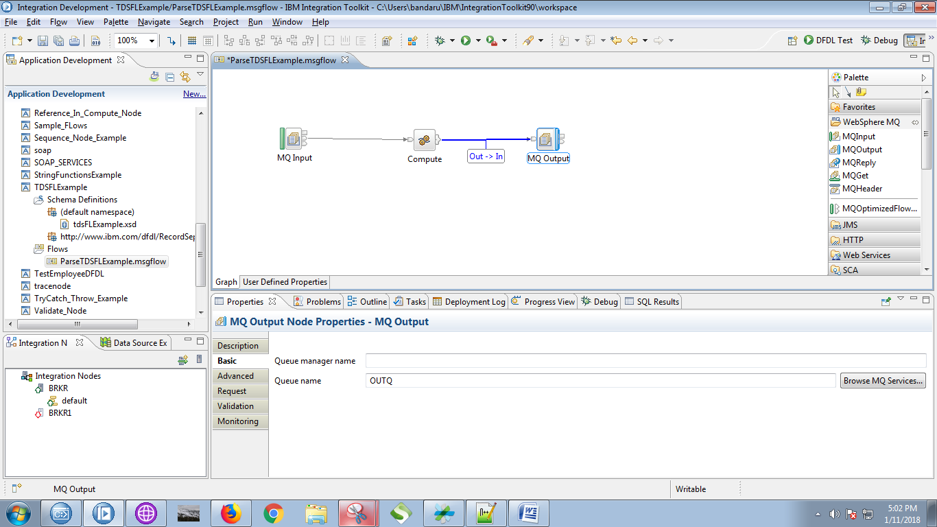

37. Copy the following code in compute node.

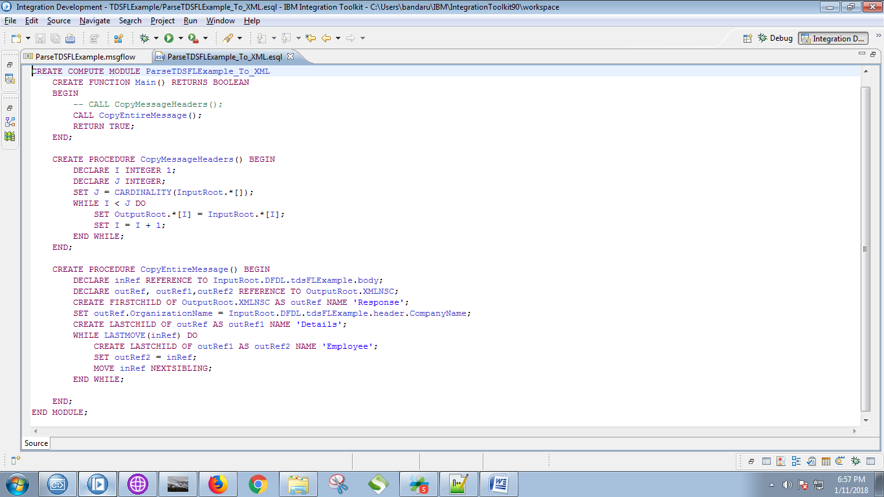

CREATE PROCEDURE CopyEntireMessage() BEGIN

DECLARE inRef REFERENCE TO InputRoot.DFDL.tdsFLExample.body;

DECLARE outRef, outRef1,outRef2 REFERENCE TO OutputRoot.XMLNSC;

CREATE FIRSTCHILD OF OutputRoot.XMLNSC AS outRef NAME 'Response';

SET outRef.OrganizationName = InputRoot.DFDL.tdsFLExample.header.CompanyName;

CREATE LASTCHILD OF outRef AS outRef1 NAME 'Details';

WHILE LASTMOVE(inRef) DO

CREATE LASTCHILD OF outRef1 AS outRef2 NAME 'Employee';

SET outRef2 = inRef;

MOVE inRef NEXTSIBLING;

END WHILE;

END;

38. Right click on your application and and choose "Deploy" option.

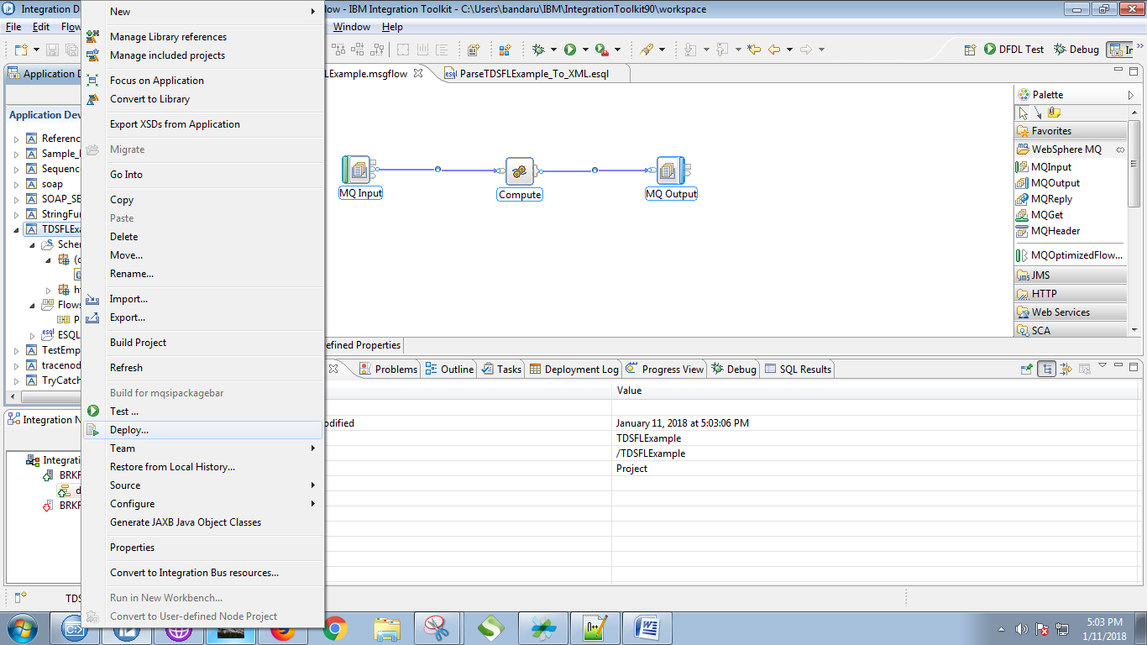

39. Choose your running broker and execution group and click on "Finish"button.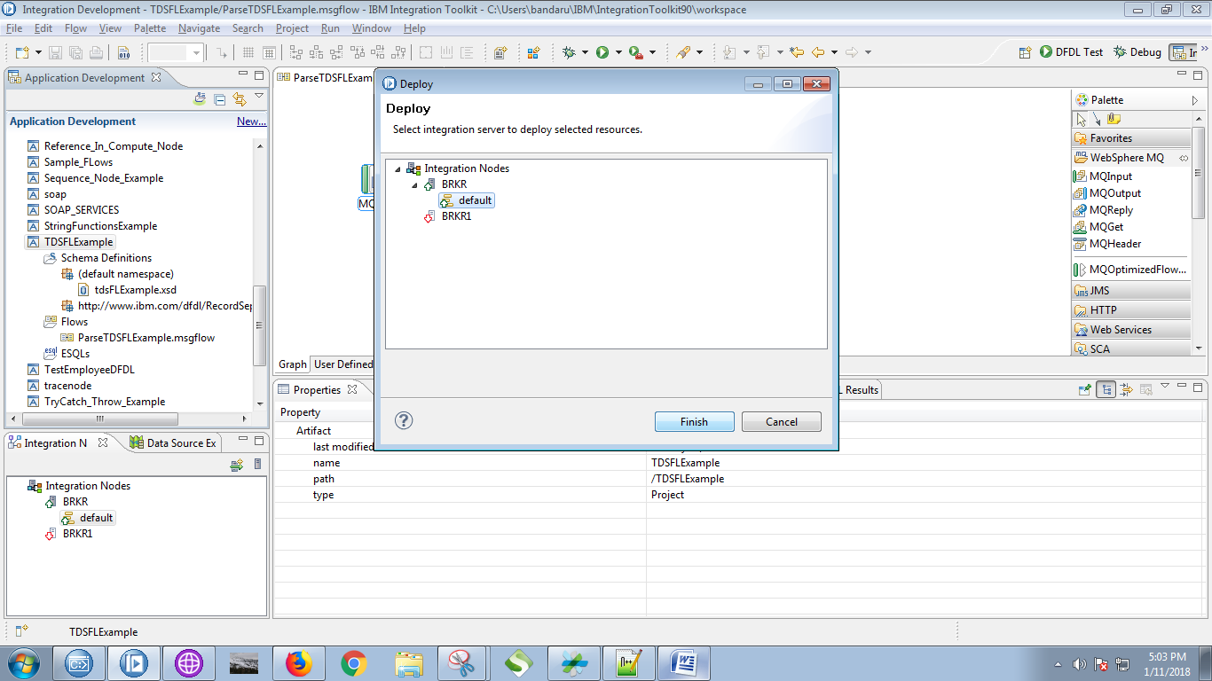

40. Create respective queues in WebSphere MQ Explorer.

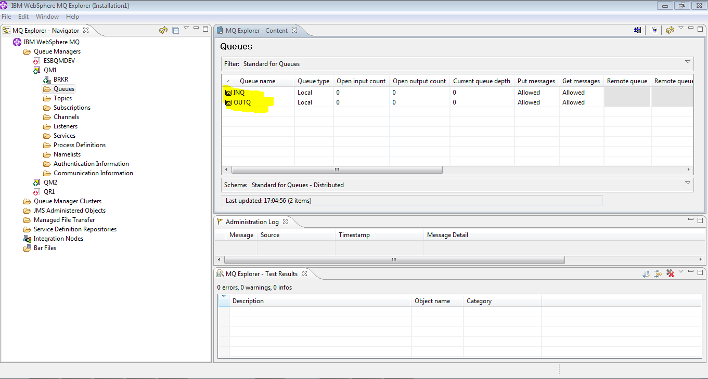

41. Open RFTUtill and select input queue.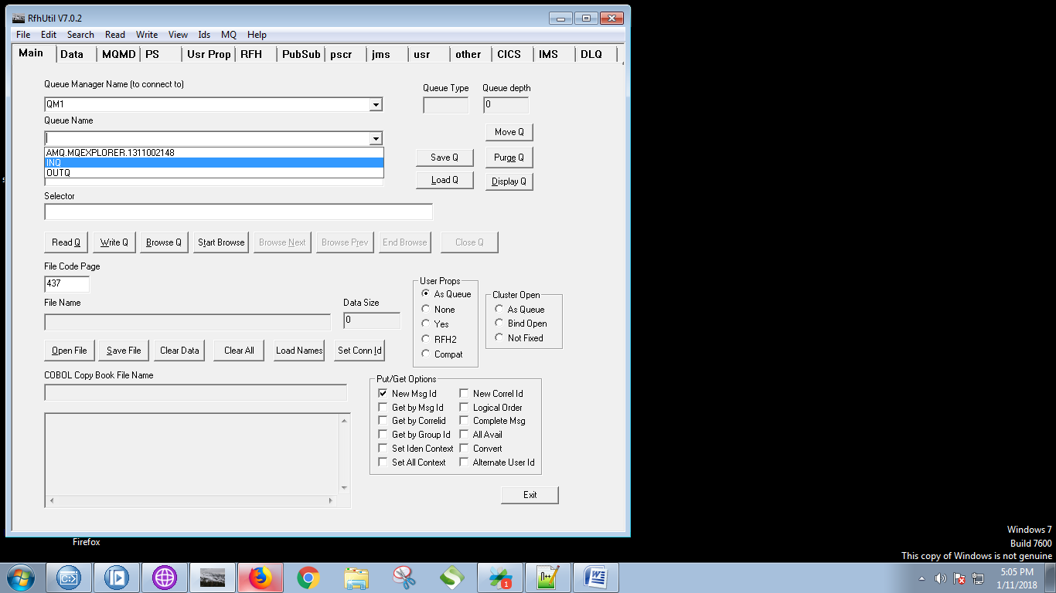

42. Select your tds file by clicking "Open File" and hit "Write Q".

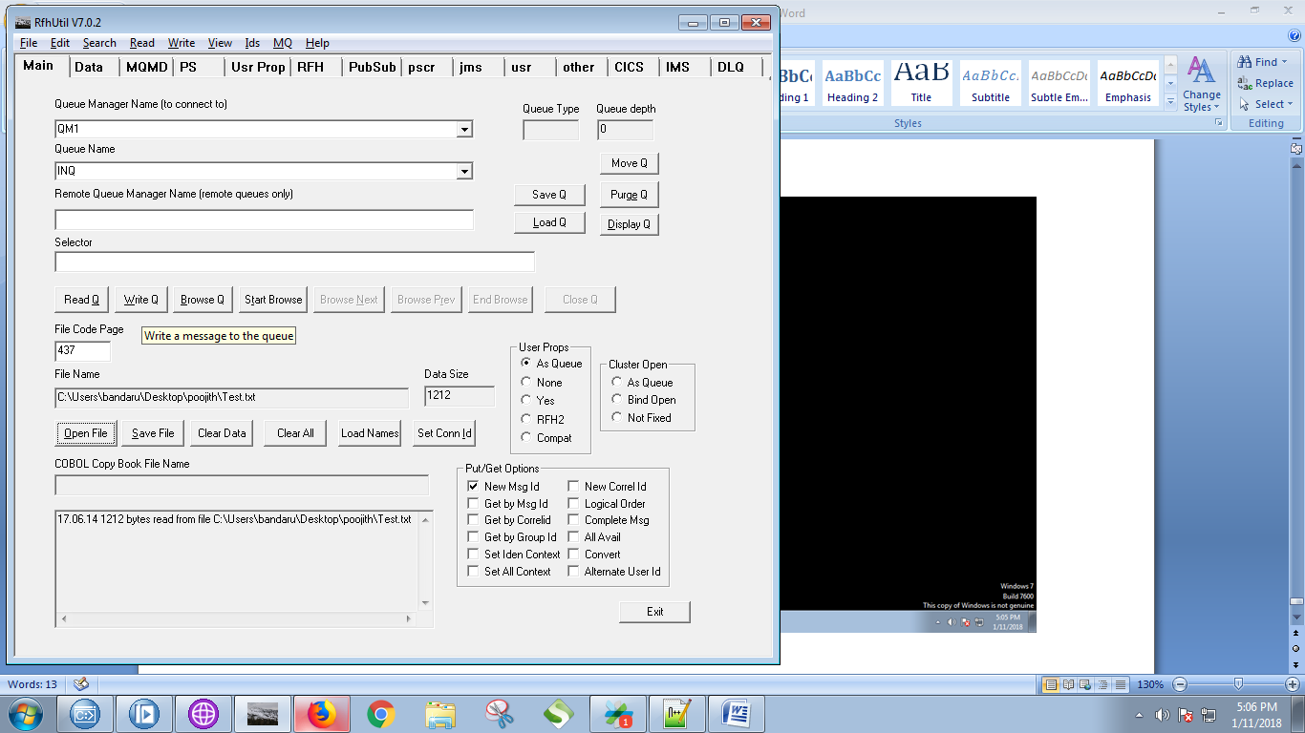

43. Output of the MQInput node can be seen in debug mode.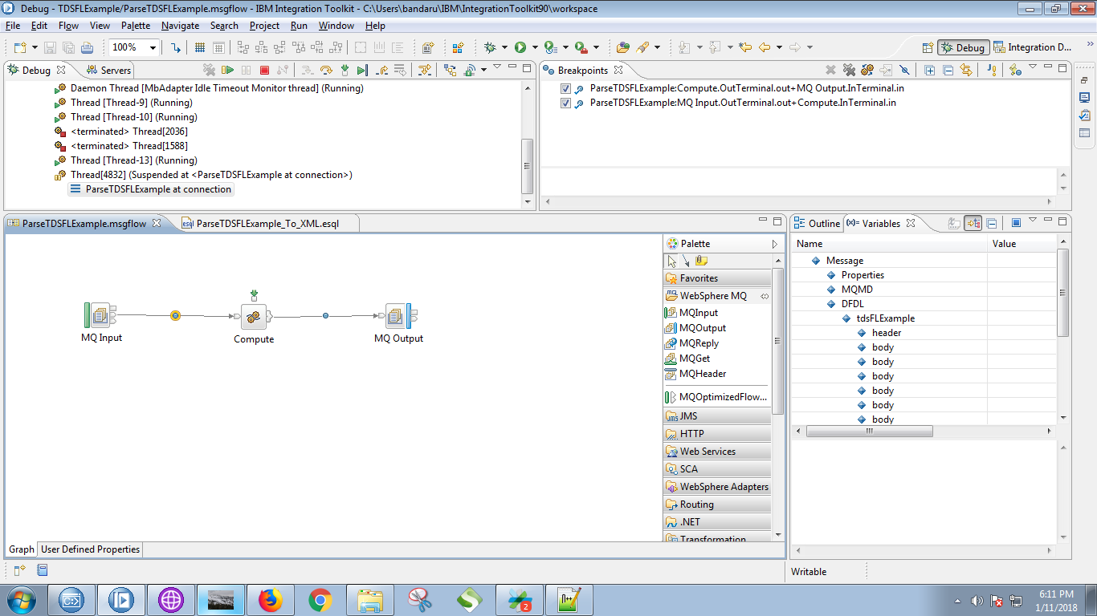

44. Output of the compute node can be seen as follows in debug mode.

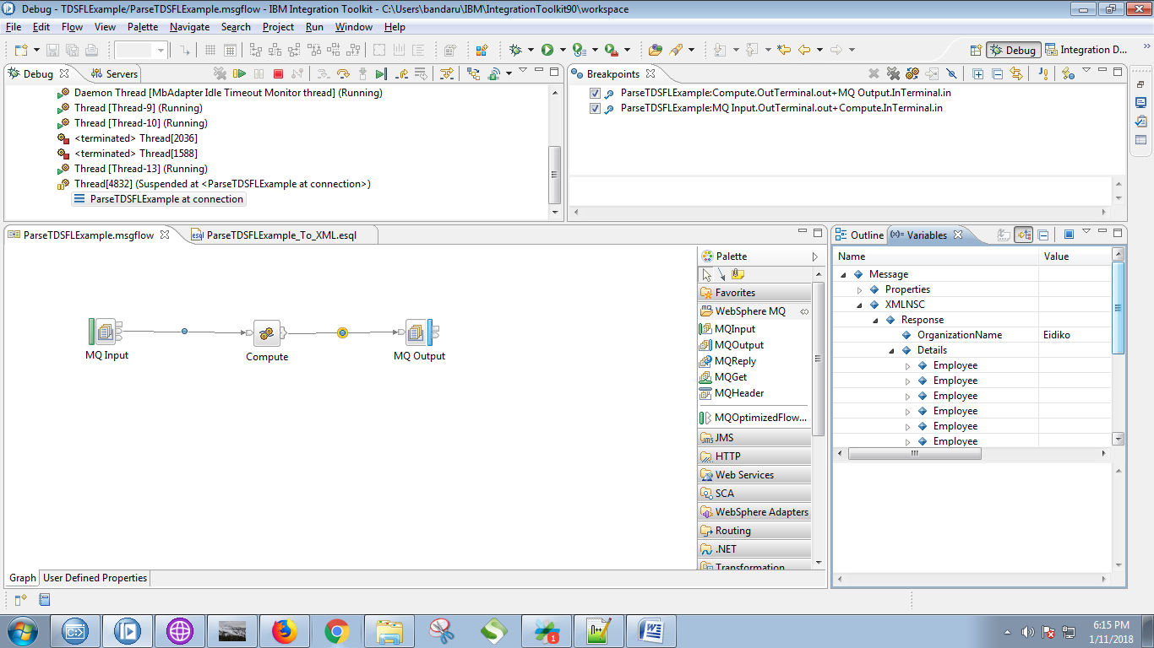

45. Select output queue in RFHUtil and click on "Browse Q" button.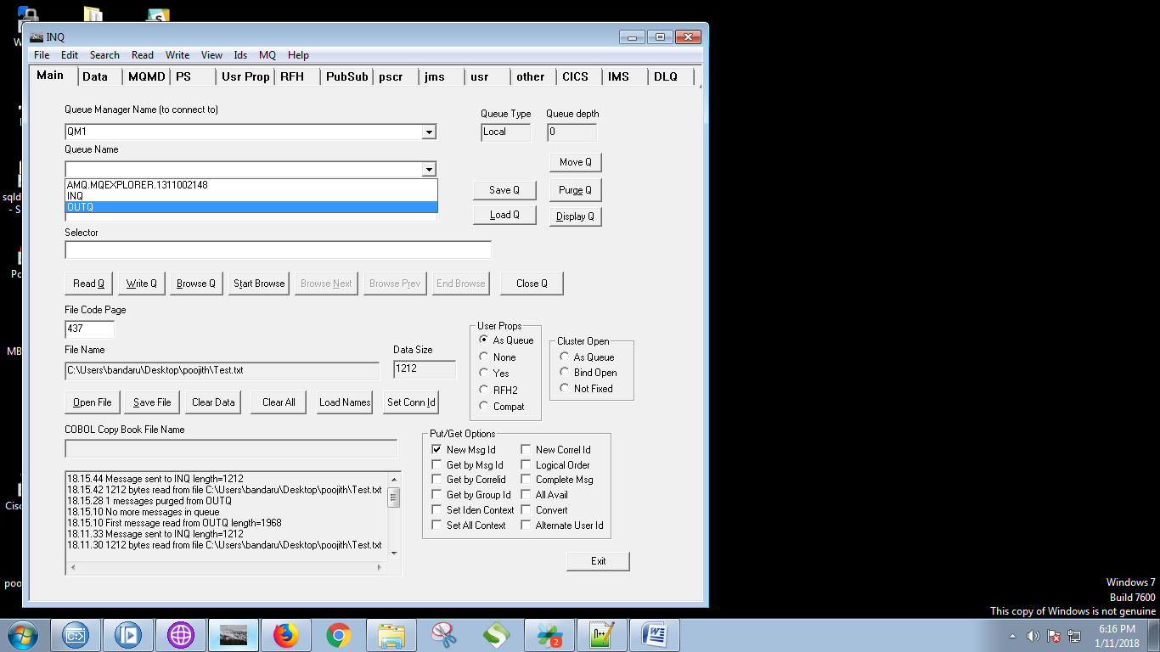

46.Youe output will be displayed on "Data" tab of the RFHUtil.

